**STAT 477/STAT 577**

**HW 4**

**Neha Maddali**

1. Women’s Health Initiative Study

a. Contingency Table

= 0.01257936

${\hat{p}}_{placebo}$ = 0.01086152

b. Null Hypothesis: H0:

Alternative Hypothesis: Ha:

Test Statistic: 0.9124514

P-value: 0.3394648

Conclusion: There is no significant evidence of a difference in the proportion of women with cancer between the hormone and placebo groups.

c. Confidence Interval: (-0.001148286, 0.004583966)

Interpretation: The 90% confidence interval for the difference in proportion of women with cancer between the hormone therapy group and the placebo group ranges from approximately -0.001 to 0.005. Since this interval contains zero, we conclude that there is insufficient evidence to claim a significant difference in the proportion of women with cancer between the two groups at a 90% confidence level.Top of Form

d. Confidence Interval: (0.915308, 1.465442)

Interpretation: In this population, we are 90% confidence the probability (risk) of a person developing cancer in hormone therapy group is between 0.915308 1.465442 times the probability (risk) of a person developing cancer in the placebo therapy group.

e. Confidence Interval: (0.9143634, 1.472065)

Interpretation: We are 90% confidence the odds of a person developing cancer in hormone therapy group is between 0.9143634 and 1.472065 times the odds of a person developing cancer in placebo therapy group in this population. The confidence interval for the population odds ratio contains 1, implying that ${\hat{p}}_{hormone}= {\hat{p}}_{placebo}$ is a reasonable conclusion given our data.

2. Titanic

a. Mosaic Plot

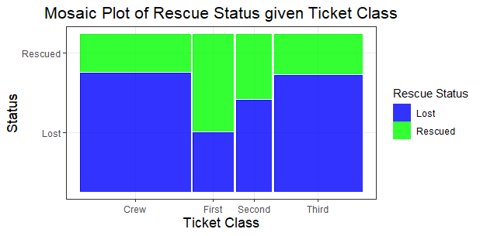

Interpretation: There is a significant difference in the width of the horizontal segments between ticket classes, suggesting that there is a difference in the proportion of passengers rescued among the classes.

b. Null Hypothesis: H0: pfirst = psecond = p­third = pcrew

Alternative Hypothesis: pfirst ≠ psecond ≠ p­third ≠ pcrew

Test Statistic: 187.7932

P-value: 1.829345e-40

Conclusion: There is strong evidence that suggests that the proportion of passengers rescued was not the same among the different ticket classes.

c. Pairwise Tests

There are significant differences in the proportion of passengers rescued between first class and crew, second class and crew, first class and second class, and third class and both first and second class.

d. Movie correct?

Yes, based on the results of the pairwise comparisons, the proportion of passengers rescued differs significantly among ticket classes. The movie’s portrayal of a potential difference in the rescue rates among ticket classes is supported.

3. Premarital Sex Attitudes

a. Conditional Distribution of Attitudes for Catholic



b. Conditional Distribution of Attitudes for Protestant



c. Mosaic Plot

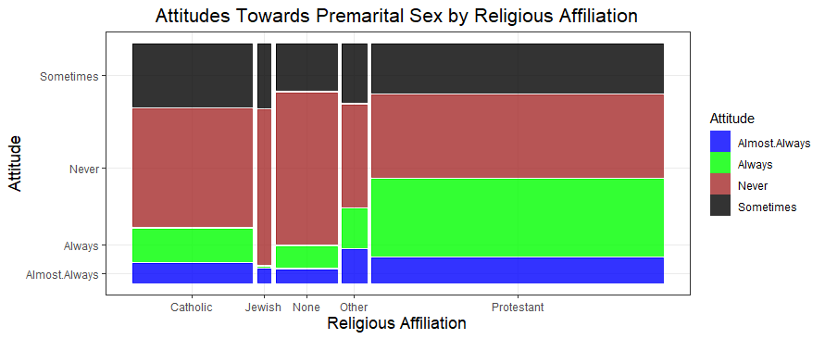

Interpretation: There is a significant difference in the width of the horizontal segments between religious affiliation, suggesting that there is a difference in the proportion of attitudes towards premarital sex among the religious affiliations.

d. Null Hypothesis: H0: pcatholic = pjewish = pnone = pother = pprotestant

Alternative Hypothesis: Ha: pcatholic ≠ pjewish ≠ pnone ≠ pother ≠ pprotestant

Test Statistic: 157.0173

P-value: 2.126751e-27

Conclusion: There is strong evidence that suggest that the proportion of attitudes towards premarital sex differ across religious affiliation groups.

e. Cell(s) with Expected Value < 5?



Religion: Jewish, Wrong: Always has an expected value less than 5.